|  |
| --- |
| Video Game Design |
| Bellevue Washington |
|  |
|  |
| **2014** |

TABLE OF CONTENTS

1 Purpose 3

2 How to Play 4

2.1 How to Play4

2.2 Elements and Mechanics4

2.3 Gameplay5

**3 Self-Evaluation**  **6**

3.1 Evaluation-Criteria-Based Reflection6

3.2 Individual Reflections6

**4 Storyboard**  **7**

**5 Hardware and Software**  **10**

5.1 Hardware10

5.2 Software10

5.3 Cost of Development11

**6 References**  **12**

**7 Copyright Permission Letters**  **13**

**8 Content Created by Non-Team-Members 14**

**9 Evidence of Testing**  **15**

**10 Plan of Work Log**  **16**

**11 Student Copyright Checklist**  **17**

**1 PURPOSE**

The foundation of the game came from the idea of using click and drag physics based mechanics in an action setting, instead of having the player solve puzzles like many games that already exist[1]. This eventually led to having a bunny given telekinetic abilities, escaping from the laboratory, who would fling objects at its enemies to “subdue”[2] them.

This video game was designed from the start to be entertaining for both the developers and the players. The artwork was fun make and look at, the audio provided many needed laughs to the team, and the programming offered challenges that everyone was able to participate in. As for the player, the game is meant for people of all ages[3], and offers something new upon every play through due to the exceptional physics based AI given to the enemies, and keeps the player engaged through beautifully illustrated and original 2D graphics and both engaging and intuitive click and drag gameplay.

**2 HOW TO PLAY**

**2.1 CONTROLS**

<LEFT MOUSE BUTTON>

IN-GAME:

Picks up the object the cursor is over (hold)

Carries the held object (drag)

Throws the held object (release)

MENU[4]:

Activates the button the cursor is over

<ESCAPE>

IN-GAME:

Opens the menu

MENU:

Resumes the game

**2.2 ELEMENTS AND MECHANICS**

The game is designed to have a natural progression in difficulty with action based gameplay imbedded with intuitive problem solving elements and lab safety rules.

**Walls** Invisible surfaces which confine the levels, preventing objects and enemies from exiting the player’s field of view through unwanted areas.

**Basic Objects** Items that deal damage to enemies through blunt force. These deal varying amounts of damage depending on how hard they’re thrown and the size of said object. The size of the object also affects the player’s ability to lift it, making it considerably more difficult to throw a sofa than it is to toss a potato. Many of these objects will also fade out, or break canonically speaking, if they’re thrown hard enough.

**Special Objects** Unique objects which eliminate enemies in ways other than blunt force. These include beakers which break upon impact and deal acidic damage to unarmored enemies, and the black hole which turns all enemies into noodles.

**Enemies** Come in the form of scientists and SWAT teams. Their goal is to capture the bunny and the player’s goal is to prevent them from doing so. The player wins when all enemies are eliminated and looses when they make contact with the bunny. Different enemies have different abilities, such as the hazmat scientist’s immunity to acids until their mask is broken.

**2.3 GAMEPLAY**

The primary goal of the game is to eliminate all of the enemies and proceed to the next level. This is done by throwing onscreen objects at the enemies. The player’s strength increases from level to level, allowing them to pick up larger objects more efficiently throughout. The player’s interaction with the game is click and drag based, making it highly accessible. Brute force works most of the time, although the enemies are smart and will many times surprise the player, causing them to rethink their strategy.

**3 SELF-EVALUATION**

**3.1 EVALUATION-CRITERIA-BASED REFLECTION**

**Documentation** The documentation follows the given criteria down to the finest detail. The plan of work sheet used is the one provided by TSA and the information listed is easy to follow and matches what is presented in the game. We anticipate points in the high forty’s, in hopes that we didn’t misunderstand any of the instructions.

**Game Design** The game is easy to pick up and play, with minimal controls. Its artwork is well designed and fun to look at, and the levels and game mechanics are innovative, allowing variation between levels. The story is simplistic yet original, and presented in an engaging way. The gameplay itself provides a unique experience and allows player creativity and the enemy’s erratic behavior keeps the player engaged. All of these result in a unique experience, and we anticipate at least forty-five points in this category with definite tens in Technical Skill and Creativity.

**Bonus** We are in hopes that our “exceptional game features” net us ten points.

**Semifinalist Interview** We’re anticipating a good interview, but you’ll have to wait and see.

**3.2 INDIVIDUAL REFLECTIONS**

**Programmer** With three years of programming under my belt, I was ready to make my first game. After joining this project, I felt like I had a true team, one with people who would give everything they’ve got, just like me. At the mention of physics, I got scared but agreed to stay in the team. In a matter of months, my programming skills have doubled and now I can proudly say that I have created a video game.

**Artist, Designer & Producer** Coordinating this project was no easy task. As my first video game, this project offered a lot of experience and required me to put in everything I’ve got. I am proud of our result, and we triumphed as a team. Communications skills are essential and I feel that mine have evolved over the course of the last few months, and the same goes for my design techniques and skills.

**Sound Designer** My experience with the production of this game was an interesting one, if not intimidating. I was brought out into a new frontier for my skills. Though there are some things that I would definitely improve on, I’m proud of my work and even more of the entire game.

**Quality Assurance** Working with the crew has been enriching. The video game was a little bit more difficult to produce than we anticipated, but once we got our feet on the ground, we were able to take off with it.

**5 HARDWARE AND SOFTWARE**

**5.1 HARDWARE**

AMD FX™-8350 Eight-Core based desktop

Intel® Core i7 4700MQ based laptop

Intel® Core i7 3630QM based laptop

Intel® Core i5 4200U based laptop

Intel® Pentium M

Wacom Bamboo One CTF 430

**5.2 SOFTWARE**

Operating Systems:

Windows 7 (64bit)

Windows 8 (64bit)

Ubuntu 13.10 (32bit)

Paint.NET 3.5

Sublime Text 3

Adobe Illustrator CS6 (64bit)

Notepad

FL Studio Fruity Edition 10.0.9

Audacity 2.0.5

Freemake Video Converter 4.1.00

Microsoft Office Word 2007

Adobe Reader XI

Collaborative Tools:

Skype

GitHub 1.9.1

**5.3 COST OF DEVELOPMENT**

All hardware and software used was purchased prior to starting the project or was free of cost. The cost of development was only the cost of electricity and this documentation (a binder, DVD, ink, and a few sheets of paper). This cost is insignificant. However, it did cost $250 to hand you this documentation.

**6 REFERENCES**

**Love2D 0.9** Created by LÖVE Development Team and attainable at love2d.org

**Box2D 2.3** Created by Erin Catto and attainable at box2d.org

**7 COPYRIGHT PERMISSION LETTERS**

Both Love 2D and Box2D are under the zlib license, which is a permissive free software license and therefore do not require permission to use or redistribute. All music used is under a Creative Commons copyright license, which grants us full use of them, although not for commercial purposes. To be specific, the song “O Fortuna” is under an Attribution-NonCommercial-NoDerivatives International License, which prevents the redistribution of the song through the form of remixes. In addition, both “Blasteroids (Funkadelik Harmonica 2010)” and “Pandora's Ficka” are under an Attribution-NonCommercial-Share Alike United States License, which does allow the redistribution of remixes.

**8 CONTENT CREATED BY NON-TEAM-MEMBERS**

**“O Fortuna”**(by [Dr. Phibes and The Ten Plagues of Egypt](http://freemusicarchive.org/music/Dr_Phibes_and_The_Ten_Plagues_of_Egypt/))

**“Blasteroids (Funkadelik Harmonica 2010)”** (by [The Subversive Elements](http://freemusicarchive.org/music/The_Subversive_Elements/))

**“Pandora's Ficka”** (by [Rune-Bertil's](http://freemusicarchive.org/music/Rune-Bertils/))

**9 EVIDENCE OF TESTING**

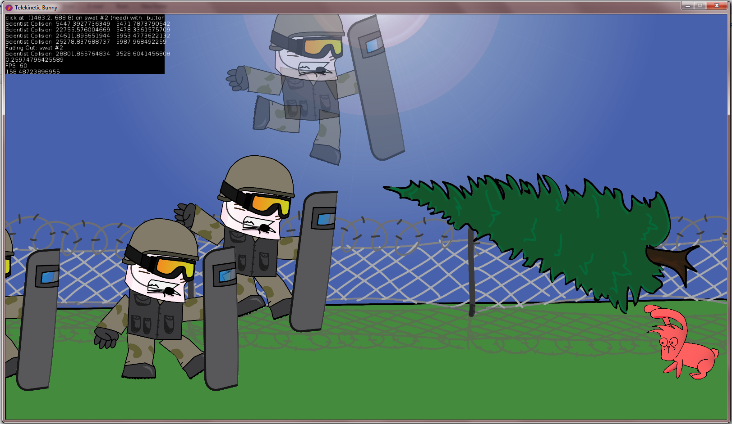

1. Jenga anybody?
2. Our game is meant for everyone, so let’s just pretend their passing out or fading out of existence to put it literally and make it sound non-violent.
3. Just to clarify, likely ages between 3 and 90, this makes up most of the people that may be interested in our video game.
4. Within the menu, you may restart the level you are on, quit the game, change the resolution, and toggle fullscreen mode.